Q1.
import pandas as pd
import random
import heapq
import networkx as nx
import matplotlib.pyplot as plt
sections = [f"S{i}" for i in range(1, 15)]
data = []
for i in range(len(sections) - 1):
for j in range(i + 1, len(sections)):
if random.random() < 0.3:
data.append(
{
"From": sections[i],
"To": sections[j],
"Distance": random.randint(5, 25),
}
)
df = pd.DataFrame(data)
df.to_csv("warehouse_routes.csv", index=False)
heuristics = {s: random.randint(1, 20) for s in sections}
def build_graph(filename):
data = pd.read_csv(filename)
G = nx.Graph()
for _, row in data.iterrows():
G.add_edge(row["From"], row["To"], weight=row["Distance"])
return G
G = build_graph("warehouse_routes.csv")
def astar_with_count_simple(G, start, goal, heuristics):
pq = [(heuristics[start], start, [start], 0)]
visited = set()
explored = 0
while pq:
est, node, path, cost = heapq.heappop(pq)
explored += 1
if node in visited:
continue
visited.add(node)
if node == goal:
return path, cost, explored
for neighbor in G.neighbors(node):
dist = G[node][neighbor]["weight"]
new_cost = cost + dist
est_total = new_cost + heuristics[neighbor]
heapq.heappush(pq, (est_total, neighbor, path + [neighbor], new_cost))
return None, float("inf"), explored
for node in G.nodes():
neighbors = [(n, G[node][n]["weight"]) for n in G.neighbors(node)]
print(f"{node} -> {neighbors}")
matrix = nx.to_pandas_adjacency(G, weight="weight")
def visualize_graph_simple(G, heuristics, path=None):
pos = nx.spring_layout(G, seed=42)
nx.draw(
G,
pos,
with_labels=True,
node_color=[heuristics[n] for n in G.nodes()],
cmap=plt.cm.Blues,
node_size=800,
font_weight="bold",
)
edge_labels = nx.get_edge_attributes(G, "weight")
nx.draw_networkx_edge_labels(G, pos, edge_labels=edge_labels)
if path:
path_edges = list(zip(path, path[1:]))
nx.draw_networkx_edges(G, pos, edgelist=path_edges, edge_color="red", width=3)
plt.title("Warehouse Graph (Node Color = Heuristic Value)")
plt.axis("off")
plt.show()
start_node = "S1"
goal_node = "S10"
path, cost, explored = astar_with_count_simple(G, start_node, goal_node, heuristics)
visualize_graph_simple(G, heuristics, path)
S1 -> [('S5', 9), ('S7', 5), ('S8', 13), ('S10', 12)]
S5 -> [('S1', 9), ('S3', 20), ('S8', 10), ('S9', 10), ('S14', 18)]
S7 -> [('S1', 5), ('S3', 10), ('S9', 24), ('S10', 6), ('S12', 21), ('S14', 8)]
S8 -> [('S1', 13), ('S3', 21), ('S4', 5), ('S5', 10), ('S14', 8)]
S10 -> [('S1', 12), ('S3', 5), ('S7', 6), ('S11', 6)]
S2 -> [('S9', 5), ('S11', 9)]
S9 -> [('S2', 5), ('S3', 21), ('S5', 10), ('S6', 19), ('S7', 24)]
S11 -> [('S2', 9), ('S6', 10), ('S10', 6), ('S12', 24), ('S13', 13), ('S14', 11)]
S3 -> [('S4', 22), ('S5', 20), ('S7', 10), ('S8', 21), ('S9', 21), ('S10', 5), ('S14', 21)]
S4 -> [('S3', 22), ('S8', 5)]
S14 -> [('S3', 21), ('S5', 18), ('S7', 8), ('S8', 8), ('S11', 11), ('S13', 24)]
S6 -> [('S9', 19), ('S11', 10), ('S12', 14), ('S13', 19)]
S12 -> [('S6', 14), ('S7', 21), ('S11', 24), ('S13', 10)]
S13 -> [('S6', 19), ('S11', 13), ('S12', 10), ('S14', 24)]
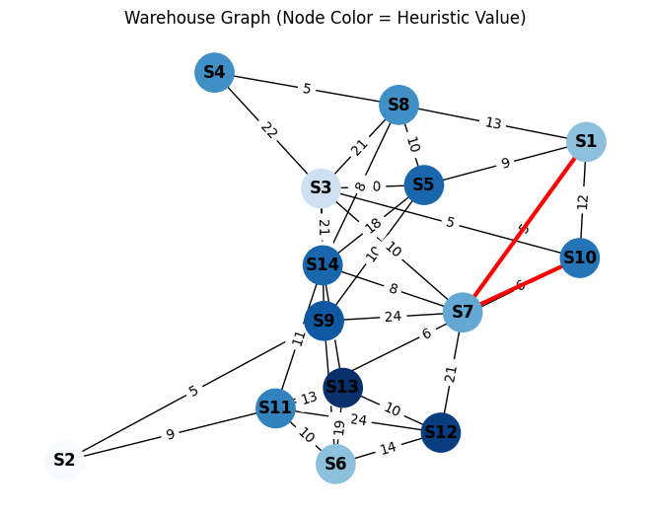
Q2.
import pandas as pd
import random
import heapq
import networkx as nx
import matplotlib.pyplot as plt
intersections = [f"I{i}" for i in range(1, 18)]
data = []
for i in range(len(intersections)):
for j in range(len(intersections)):
if i != j and random.random() < 0.2: # 20% chance of a road
travel_time = random.randint(2, 15)
data.append(
{
"From": intersections[i],
"To": intersections[j],
"Travel_Time": travel_time,
}
)
df = pd.DataFrame(data)
df.to_csv("smartcity_roads.csv", index=False)
heuristics = {node: random.randint(1, 20) for node in intersections}
def build_graph(filename):
data = pd.read_csv(filename)
G = nx.DiGraph()
for _, row in data.iterrows():
G.add_edge(row["From"], row["To"], weight=row["Travel_Time"])
return G
G = build_graph("smartcity_roads.csv")
for node in G.nodes():
neighbors = [(n, G[node][n]["weight"]) for n in G.neighbors(node)]
print(f"{node} -> {neighbors}")
print(nx.to_pandas_adjacency(G, weight="weight"))
def astar_search(G, start, goal, heuristics):
pq = [(heuristics[start], start, [start], 0)] # (f, node, path, g)
visited = set()
explored = 0
while pq:
pq.sort(key=lambda x: x[0])
f, node, path, cost = pq.pop(0)
explored += 1
if node == goal:
return path, cost, explored
if node in visited:
continue
visited.add(node)
for neighbor in G.neighbors(node):
travel = G[node][neighbor]["weight"]
new_cost = cost + travel
f_score = new_cost + heuristics.get(neighbor, 0)
pq.append((f_score, neighbor, path + [neighbor], new_cost))
return None, float("inf"), explored
start, goal = "I1", "I10"
path, cost, explored = astar_search(G, start, goal, heuristics)
def near_optimal_routes(G, start, goal, heuristics, factor=1.2):
best_path, best_cost, _ = astar_search(G, start, goal, heuristics)
if not best_path:
return []
limit = best_cost * factor
routes = []
def explore(node, path, cost):
if cost > limit:
return
if node == goal:
routes.append((path, cost))
return
for neighbor in G.neighbors(node):
if neighbor not in path:
travel = G[node][neighbor]["weight"]
explore(neighbor, path + [neighbor], cost + travel)
explore(start, [start], 0)
return [(p, c) for p, c in routes if c <= limit]
near_routes = near_optimal_routes(G, start, goal, heuristics)
for p, c in near_routes:
print(f" Path: {p}, Travel time: {c}")
def check_consistency(G, heuristics):
bad_edges = []
for u, v, d in G.edges(data=True):
cost = d["weight"]
if heuristics[u] > cost + heuristics[v]:
bad_edges.append((u, v, heuristics[u], cost, heuristics[v]))
return bad_edges
violations = check_consistency(G, heuristics)
if not violations:
print("✅ Heuristic is consistent for all edges.")
else:
print("⚠ Inconsistent heuristic edges:")
for u, v, hu, c, hv in violations:
print(f" {u}->{v}: h({u})={hu}, cost={c}, h({v})={hv}")
def visualize_graph(G, heuristics, path=None):
pos = nx.spring_layout(G, seed=42)
node_colors = [heuristics[n] for n in G.nodes()]
# Draw nodes (color = heuristic value)
nx.draw(
G,
pos,
with_labels=True,
node_color=node_colors,
cmap=plt.cm.Blues,
node_size=800,
font_weight="bold",
)
# Label edges with travel times
labels = nx.get_edge_attributes(G, "weight")
nx.draw_networkx_edge_labels(G, pos, edge_labels=labels)
# Highlight the optimal path
if path:
path_edges = list(zip(path, path[1:]))
nx.draw_networkx_edges(G, pos, edgelist=path_edges, edge_color="r", width=3)
plt.title("Smart City Road Network (A* Optimal Path Highlighted)")
plt.axis("off")
plt.show()
# Show graph
visualize_graph(G, heuristics, path)
I1 -> [('I3', 8), ('I4', 8), ('I17', 6)]
I3 -> [('I1', 6), ('I9', 11)]
I4 -> [('I5', 12), ('I6', 13), ('I8', 8), ('I10', 2), ('I12', 7), ('I14', 11)]
I17 -> [('I16', 14)]
I2 -> [('I3', 2), ('I7', 15)]
I7 -> [('I2', 10), ('I3', 11), ('I6', 8), ('I15', 2), ('I17', 7)]
I9 -> [('I2', 11), ('I6', 9), ('I12', 6), ('I13', 14)]
I5 -> [('I13', 8), ('I14', 6)]
I6 -> [('I2', 7), ('I3', 14), ('I10', 5), ('I16', 3), ('I17', 11)]
I8 -> [('I1', 14), ('I10', 15), ('I14', 4)]
I10 -> [('I3', 10), ('I6', 15), ('I13', 5), ('I14', 11)]
I12 -> [('I1', 14), ('I3', 8), ('I5', 3), ('I10', 3)]
I14 -> [('I1', 9), ('I8', 5)]
I13 -> [('I4', 12), ('I9', 2), ('I12', 14)]
I16 -> [('I4', 12), ('I7', 11), ('I9', 9), ('I14', 9), ('I17', 3)]
I15 -> [('I3', 7), ('I4', 13), ('I11', 5), ('I14', 13), ('I16', 2)]
I11 -> [('I1', 8), ('I6', 10), ('I7', 2), ('I9', 12), ('I10', 2), ('I12', 9), ('I17', 14)]
I1 I3 I4 I17 I2 I7 I9 I5 I6 I8 I10 I12 \
I1 0.0 8.0 8.0 6.0 0.0 0.0 0.0 0.0 0.0 0.0 0.0 0.0
I3 6.0 0.0 0.0 0.0 0.0 0.0 11.0 0.0 0.0 0.0 0.0 0.0
I4 0.0 0.0 0.0 0.0 0.0 0.0 0.0 12.0 13.0 8.0 2.0 7.0
I17 0.0 0.0 0.0 0.0 0.0 0.0 0.0 0.0 0.0 0.0 0.0 0.0
I2 0.0 2.0 0.0 0.0 0.0 15.0 0.0 0.0 0.0 0.0 0.0 0.0
I7 0.0 11.0 0.0 7.0 10.0 0.0 0.0 0.0 8.0 0.0 0.0 0.0
I9 0.0 0.0 0.0 0.0 11.0 0.0 0.0 0.0 9.0 0.0 0.0 6.0
I5 0.0 0.0 0.0 0.0 0.0 0.0 0.0 0.0 0.0 0.0 0.0 0.0
I6 0.0 14.0 0.0 11.0 7.0 0.0 0.0 0.0 0.0 0.0 5.0 0.0
I8 14.0 0.0 0.0 0.0 0.0 0.0 0.0 0.0 0.0 0.0 15.0 0.0
I10 0.0 10.0 0.0 0.0 0.0 0.0 0.0 0.0 15.0 0.0 0.0 0.0
I12 14.0 8.0 0.0 0.0 0.0 0.0 0.0 3.0 0.0 0.0 3.0 0.0
I14 9.0 0.0 0.0 0.0 0.0 0.0 0.0 0.0 0.0 5.0 0.0 0.0
I13 0.0 0.0 12.0 0.0 0.0 0.0 2.0 0.0 0.0 0.0 0.0 14.0
I16 0.0 0.0 12.0 3.0 0.0 11.0 9.0 0.0 0.0 0.0 0.0 0.0
I15 0.0 7.0 13.0 0.0 0.0 0.0 0.0 0.0 0.0 0.0 0.0 0.0
I11 8.0 0.0 0.0 14.0 0.0 2.0 12.0 0.0 10.0 0.0 2.0 9.0
I14 I13 I16 I15 I11
I1 0.0 0.0 0.0 0.0 0.0
I3 0.0 0.0 0.0 0.0 0.0
I4 11.0 0.0 0.0 0.0 0.0
I17 0.0 0.0 14.0 0.0 0.0
I2 0.0 0.0 0.0 0.0 0.0
I7 0.0 0.0 0.0 2.0 0.0
I9 0.0 14.0 0.0 0.0 0.0
I5 6.0 8.0 0.0 0.0 0.0
I6 0.0 0.0 3.0 0.0 0.0
I8 4.0 0.0 0.0 0.0 0.0
I10 11.0 5.0 0.0 0.0 0.0
I12 0.0 0.0 0.0 0.0 0.0
I14 0.0 0.0 0.0 0.0 0.0
I13 0.0 0.0 0.0 0.0 0.0
I16 9.0 0.0 0.0 0.0 0.0
I15 13.0 0.0 2.0 0.0 5.0
I11 0.0 0.0 0.0 0.0 0.0
Path: ['I1', 'I4', 'I10'], Travel time: 10
⚠ Inconsistent heuristic edges:
I4->I10: h(I4)=11, cost=2, h(I10)=6
I7->I6: h(I7)=15, cost=8, h(I6)=5
I7->I15: h(I7)=15, cost=2, h(I15)=10
I9->I12: h(I9)=12, cost=6, h(I12)=5
I6->I16: h(I6)=5, cost=3, h(I16)=1
I14->I8: h(I14)=11, cost=5, h(I8)=3
I15->I16: h(I15)=10, cost=2, h(I16)=1
I11->I10: h(I11)=15, cost=2, h(I10)=6
I11->I12: h(I11)=15, cost=9, h(I12)=5
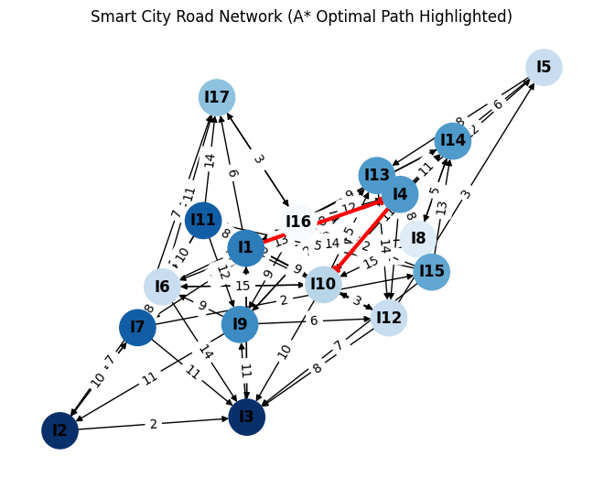
Q3.
pandas as pd
import random
import networkx as nx
import matplotlib.pyplot as plt
from collections import deque
teams = ['Analytics', 'Design', 'Support', 'Development', 'QA', 'Management']
channels = [f'Channel_{i}' for i in range(1, 16)]
data = []
for channel in channels:
communicating_teams = random.sample(teams, random.randint(2, 4))
for t in communicating_teams:
data.append({'Team': t, 'Channel': channel})
df = pd.DataFrame(data)
df.to_csv('team_comm.csv', index=False)
print("✅ Dataset 'team_comm.csv' created!")
print(df.head())
print("----------------------------------------------------------")
def build_graph(filename):
data = pd.read_csv(filename)
G = nx.Graph()
for channel, group in data.groupby('Channel'):
members = group['Team'].tolist()
for i in range(len(members)):
for j in range(i + 1, len(members)):
G.add_edge(members[i], members[j], channel=channel)
return G
G = build_graph('team_comm.csv')
print("📡 Team Communication Links:")
for team in G.nodes():
print(f"{team}: {G.degree(team)} links")
def bfs_shortest_path(G, start, goal):
visited = set([start])
queue = deque([[start]])
while queue:
path = queue.popleft()
node = path[-1]
if node == goal:
return path
for neighbor in G.neighbors(node):
if neighbor not in visited:
visited.add(neighbor)
queue.append(path + [neighbor])
return None
start, goal = 'Analytics', 'QA'
path = bfs_shortest_path(G, start, goal)
if path:
print(f"🔗 Shortest communication chain from {start} to {goal}: {path}")
else:
print(f"❌ No communication chain between {start} and {goal}.")
def bfs_reachable(G, source):
visited = set([source])
queue = deque([source])
while queue:
node = queue.popleft()
for neighbor in G.neighbors(node):
if neighbor not in visited:
visited.add(neighbor)
queue.append(neighbor)
return visited
reachable = bfs_reachable(G, 'Analytics')
print(f"🌐 Teams reachable from Analytics: {reachable}")
print(f"Total reachable teams: {len(reachable)}")
print("----------------------------------------------------------")
# ----------------------------------------------------------
# (d) Adjacency Matrix
# ----------------------------------------------------------
adj_matrix = nx.to_pandas_adjacency(G, dtype=int)
print("🧮 Adjacency Matrix:")
print(adj_matrix)
print("----------------------------------------------------------")
# ----------------------------------------------------------
# (e) Visualization
# ----------------------------------------------------------
def visualize_graph(G, path=None):
pos = nx.spring_layout(G, seed=42)
plt.figure(figsize=(8, 6))
# Node colors: highlight those in the shortest path
color_map = ['red' if path and node in path else 'skyblue' for node in G.nodes()]
nx.draw(
G, pos, with_labels=True, node_color=color_map,
node_size=1000, font_weight='bold', font_size=10
)
# Highlight path edges
if path:
path_edges = list(zip(path, path[1:]))
nx.draw_networkx_edges(G, pos, edgelist=path_edges, edge_color='r', width=3)
plt.title("Organizational Communication Network (Shortest Chain Highlighted)")
plt.axis('off')
plt.show()
# Show graph
visualize_graph(G, path)
✅ Dataset 'team_comm.csv' created!
Team Channel
0 QA Channel_1
1 Analytics Channel_1
2 Management Channel_2
3 Design Channel_2
4 Support Channel_2
----------------------------------------------------------
📡 Team Communication Links:
QA: 5 links
Analytics: 5 links
Design: 5 links
Management: 5 links
Development: 4 links
Support: 4 links
🔗 Shortest communication chain from Analytics to QA: ['Analytics', 'QA']
🌐 Teams reachable from Analytics: {'Management', 'QA', 'Analytics', 'Development', 'Support', 'Design'}
Total reachable teams: 6
----------------------------------------------------------
🧮 Adjacency Matrix:
QA Analytics Design Management Development Support
QA 0 1 1 1 1 1
Analytics 1 0 1 1 1 1
Design 1 1 0 1 1 1
Management 1 1 1 0 1 1
Development 1 1 1 1 0 0
Support 1 1 1 1 0 0
----------------------------------------------------------
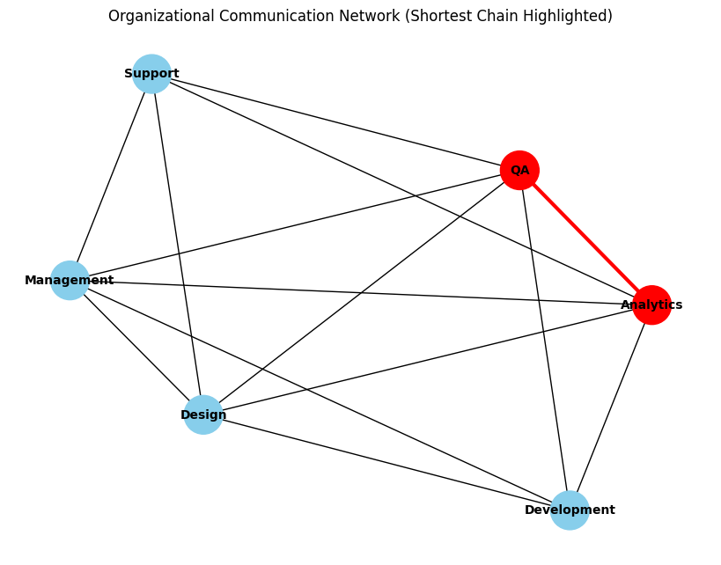
Q4.
import pandas as pd
import random
import networkx as nx
import matplotlib.pyplot as plt
from collections import deque
buildings = [
'Admin Block', 'Library', 'Hostel A', 'Hostel B', 'Cafeteria', 'Auditorium',
'Sports Complex', 'Lab 1', 'Lab 2', 'Workshop', 'Bookstore', 'Parking Lot'
]
data = []
for i in range(1, len(buildings)):
parent = buildings[random.randint(0, i - 1)]
child = buildings[i]
data.append({'From_Building': parent, 'To_Building': child})
df = pd.DataFrame(data)
df.to_csv('campus_routes.csv', index=False)
print("✅ Dataset 'campus_routes.csv' created!")
print(df.head())
print("----------------------------------------------------------")
def build_graph(filename):
data = pd.read_csv(filename)
G = nx.DiGraph()
for _, row in data.iterrows():
G.add_edge(row['From_Building'], row['To_Building'])
return G
G = build_graph('campus_routes.csv')
print("🏗 Campus Buildings and Connections:")
for node in G.nodes():
print(f"{node}: {list(G.successors(node))}")
print("----------------------------------------------------------")
def bfs_shortest_path(G, start, goal):
visited = set([start])
queue = deque([[start]])
while queue:
path = queue.popleft()
node = path[-1]
if node == goal:
return path # shortest path found
for neighbor in G.successors(node):
if neighbor not in visited:
visited.add(neighbor)
queue.append(path + [neighbor])
return None
start, goal = 'Admin Block', 'Parking Lot'
path = bfs_shortest_path(G, start, goal)
if path:
print(f"🚚 Shortest delivery route from {start} to {goal}: {path}")
else:
print(f"❌ No route from {start} to {goal}.")
for node in G.nodes():
G.nodes[node]['load'] = random.randint(1, 10)
print("📦 Delivery load factors (per building):")
for node, data in G.nodes(data=True):
print(f"{node}: {data['load']}")
def bfs_min_load_path(G, start, goal):
queue = deque([(start, [start], G.nodes[start]['load'])])
best_path, best_load = None, float('inf')
while queue:
node, path, load = queue.popleft()
if node == goal:
if load < best_load:
best_path, best_load = path, load
continue
for neighbor in G.successors(node):
if neighbor not in path:
total_load = load + G.nodes[neighbor]['load']
queue.append((neighbor, path + [neighbor], total_load))
return best_path, best_load
min_path, min_load = bfs_min_load_path(G, start, goal)
print(f"🪣 Minimum-load path from {start} to {goal}: {min_path}")
print(f"Total delivery load: {min_load}")
print("----------------------------------------------------------")
def bfs_reachable(G, start):
visited = set([start])
queue = deque([start])
while queue:
node = queue.popleft()
for neighbor in G.successors(node):
if neighbor not in visited:
visited.add(neighbor)
queue.append(neighbor)
return visited
reachable = bfs_reachable(G, 'Admin Block')
print(f"🏢 Buildings reachable from Admin Block: {reachable}")
print(f"Total reachable buildings: {len(reachable)}")
print("----------------------------------------------------------")
def visualize_graph(G, path=None):
pos = nx.spring_layout(G, seed=42)
plt.figure(figsize=(10, 6))
colors = ['red' if path and n in path else 'skyblue' for n in G.nodes()]
nx.draw(
G, pos, with_labels=True, node_color=colors,
node_size=1000, font_size=9, arrows=True, font_weight='bold'
)
if path:
edges = list(zip(path, path[1:]))
nx.draw_networkx_edges(G, pos, edgelist=edges, edge_color='r', width=3)
plt.title("Campus Logistics Network (Directed)")
plt.axis('off')
plt.show()
visualize_graph(G, path)
def has_cycle(G):
visited = set()
rec_stack = set()
def dfs(node):
visited.add(node)
rec_stack.add(node)
for neighbor in G.successors(node):
if neighbor not in visited:
if dfs(neighbor):
return True
elif neighbor in rec_stack:
return True
rec_stack.remove(node)
return False
for node in G.nodes():
if node not in visited:
if dfs(node):
return True
return False
if has_cycle(G):
print("⚠ Cycle detected! There may be a routing loop.")
else:
print("✅ No cycles detected in the logistics network.")
✅ Dataset 'campus_routes.csv' created!
From_Building To_Building
0 Admin Block Library
1 Admin Block Hostel A
2 Admin Block Hostel B
3 Admin Block Cafeteria
4 Library Auditorium
----------------------------------------------------------
🏗 Campus Buildings and Connections:
Admin Block: ['Library', 'Hostel A', 'Hostel B', 'Cafeteria']
Library: ['Auditorium', 'Workshop']
Hostel A: []
Hostel B: ['Sports Complex']
Cafeteria: ['Lab 1', 'Lab 2']
Auditorium: ['Bookstore']
Sports Complex: []
Lab 1: []
Lab 2: []
Workshop: []
Bookstore: ['Parking Lot']
Parking Lot: []
----------------------------------------------------------
🚚 Shortest delivery route from Admin Block to Parking Lot: ['Admin Block', 'Library', 'Auditorium', 'Bookstore', 'Parking Lot']
📦 Delivery load factors (per building):
Admin Block: 1
Library: 7
Hostel A: 3
Hostel B: 10
Cafeteria: 4
Auditorium: 8
Sports Complex: 10
Lab 1: 5
Lab 2: 3
Workshop: 6
Bookstore: 3
Parking Lot: 1
🪣 Minimum-load path from Admin Block to Parking Lot: ['Admin Block', 'Library', 'Auditorium', 'Bookstore', 'Parking Lot']
Total delivery load: 20
----------------------------------------------------------
🏢 Buildings reachable from Admin Block: {'Lab 2', 'Admin Block', 'Cafeteria', 'Library', 'Hostel B', 'Lab 1', 'Workshop', 'Sports Complex', 'Auditorium', 'Bookstore', 'Parking Lot', 'Hostel A'}
Total reachable buildings: 12
----------------------------------------------------------
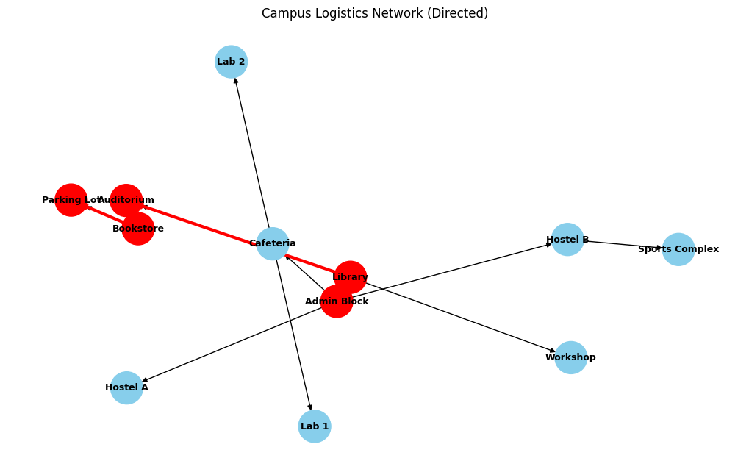
✅ No cycles detected in the logistics network.

